ALR DOC GUIDELINES FOR SUPPORT
PATCH WEAR ON VEST

The American Legion Riders (ALR) Department Executive Committee met on January 22, 2026, and updated the recommendations for wearing a Support Patch for CA DOC ALR Chapters.

- A Support Team member is recognized as an American Legion family member (i.e. TAL, SAL, or Auxiliary) who does not currently meet membership requirements to be an American Legion Rider, but who has volunteered and helped their local ALR Chapter to further the American Legion and ALR.
  - The designation of a Support Team member is awarded by the Chapter members with majority approval. The governance and control of the allowance of Support Team members is the responsibility of the awarding Chapter.
- The designation of Support Team member does not create another class of American Legion Rider. Subsequently a Support Team member is not an ALR member, has no voice, no vote, and cannot be added to a Chapter’s roster as a member.
- If a Support Team member elects to purchase and wear a vest/jacket and show representation as a Support Team member, they shall not:
  - Wear an American Legion Riders center patch or ALR DOC flares, either separately or sewn together. These are reserved only for members of the American Legion Riders Department of California.
  - Be provided with an ALR membership card

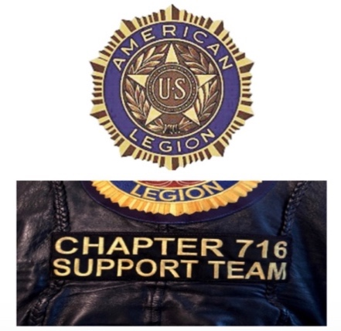
Below is a suggestion of the proper wear of the back of the Support Team member vest/jacket.

