The American Legion Riders
Department of California
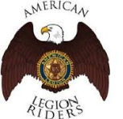
For God and Country

DEC Minutes
October 24, 2019

- Called to Order - President Rey Ruiz @ 7pm
- Invocation – Chaplain Monique Clemons
- Pause for MIA - President Rey Ruiz
- Pledge of Allegiance - Sgt. At Arms Mike Smith
- ALR Preamble - President Rey Ruiz
- Roll Call - Secretary Debbie Proffitt

President-Rey Ruiz; Vice President-Fred Branson; Sergeant-At-Arms-Mike Smith; Treasurer-Leonard Phillips; Secretary-Debbie Proffitt; Chaplain-Monique Clemons;
Judge Advocate/Area 3 Alt VP-Ralph Wenzinger; Historian/Jr Past- Mick Sobczak; Safety Officer-Rob Carrier; Service Officer-George Smith; Webmaster/Public Relations-Jim Oxley; Quartermaster-Mike Clement; Membership/Legacy Run/Awards & Certificates-Rochelle Billet-Smith;
Convention & Rally-Ken Sutton; EX Ways & Means- Vacant; Area 1 VP/Area 1 Commissioner-Bob Perryman; Area 1 Alt VP-Rory Airheart; EX Area 1 Alt VP-Bob Gault; Area Alt VP-Larry Goekler;
Area 2 VP/Area 2 Commissioner- Sean Ramsay; Area 2 Alt VP- Hy Libby;
Area 2 Alt VP-Ignacio Alvarez; Area 3 VP-Paul LaPierre; Area 3 Alt VP-Matt Dolezal; Area 3 Alt VP-JD Bennett; Area 4 VP-Joel Lopez; EX Area 5 VP-Gene Hobdy; Area 5 Alt VP-Ron Huff; Area 5 Alt VP-Larry Brandt; Area 5 Alt VP-Mike Killion; Area 5 Alt VP- John Smartt; Area 6 VP-Lino Torres; Area 6 Alt VP-Cristina Molina; Area 6 Alt VP- Dave Corbin; Area 6 Alt VP-Nancy Weatherman; EX
Area 3 Commissioner-Vince Cole; Area 4 Commissioner-Karl Wilvert; Area 5 Commissioner/Chairperson-Paul Patricio; Area 6 Commissioner-Steve Weber;
Tech Advisor-James Adames

Guests: Brian Bokkin-Secretary-Chapter 28

- Additions to the Agenda –

*Add Legat to Rider Everlasting.
*Add McDowell to sick and memorial.

- Approval of Minutes – September 20nd Minutes

Motion to approve the September 20, 2019 minutes as electronically transmitted by Mike Smith. 2nd by Fred Branson. Approved by vote of DEC.

- Financial Report – Leonard Phillips

*Getting caught up on payments.
*Debit $57,998.42; deposits $47,596.74; current balance $62,595.22
*Received 2 startup payments from the chapters voted in.
*If you went to Rally and haven’t received payment, send an email. I will verify your attendance with the secretary then send a check.
*Motion to accept the finance report as read pending audit by Leonard Phillips. 2nd by Debbie Proffitt. Passed by vote of DEC.

- Presidents Report – Rey Ruiz

- Participated on the California Legacy planning call for September & October. IF you or others want to be part of the planning and take an active role for the 2020 California Legacy Run, please email Rochelle Billet-Smith at harleysoftlady@aol.com to be added to the call. YOUR participation ensures our success.
- 09/20-22/19 attended West Coast Rally.
- 10/5/19 attended Area 1 President’s meeting
- 10/12/19 attended Area 6 President’s meeting
- 10/13/19 attended Area 5 President’s meeting
- 10/13/19 attended Chapter 421’s inaugural BBQ
- 10/19/19 attended Salute to Veterans Run
- 10/21/19 attended Funeral for Gerald Kirby Chapter 716

- Vice President Report – Fred Branson

*Supporting the community with the Lions, Rotary, etc.
*Reached out to Randy Brenneman. Waiting for a response.

- Sgt. At Arms Report – Mike Smith

*Attended the Area 1 President’s meeting. Apologized for not making it to the Area 5 and 6 meetings.

- Secretary Report – Debbie Proffitt

*Asked the Area VPs and Alt VPs that when they are helping a chapter get started, not only do the officers need to be chosen, but also the POCs. Responsibilities of the POCs need to be explained. The POCs need to be given a run through of how to order from the Quartermaster.
- Area Reports –

- Area 1 VP – Bob Perryman

*Had the Area 1 President’s meeting. Had a good turnout. 12 of 14 chapters were represented. Thanks to Rey, Mick and Mike for coming.
*Chapters are getting ready for Wreaths Across America and Halloween.
*Yountville is not a National Cemetery so needs volunteers for Wreaths Across America. May be asking the Area 1 chapters to help with Yountville. The cemetery in Dixon has plenty of help.
*Thank you to my chapter and the celebration of life for my brother. Was a very good service.
*Have a chapter that is interested in hosting Rally.
*Next President’s meeting will be at Chapter 111, Healdsburg, on February 15.

- Area 2 VP – Sean Ramsey/Hy Libby

*Participating in various funeral escorts.
*Participated in the 5k/10k footraces for Honor Our Fallen as Security.
*A District 28 member was on an Honor Flight.
*Spent time with Legion Riders from Pennsylvania
*The Heroes Open Golf Tournament is this Saturday.
*Escorted a 42-year-old Marine veteran that died of a brain aneurism. The Fire Department was present with a ladder truck.
*Two weeks ago, chapter 534 came up and were hosted with a social night and ride on the coast.
*There will be Veterans Day ceremonies at the California Central Coast Veterans Cemetery.
*Will be leading the Monterey County Veterans Day parade.

- Area 3 VP – Paul La Pierre

*Area 3 had 2 chapters at the West Coast Rally. Had lots of fun.
*Ch 221 had their annual poker run. It was well attended.
*Several chapters from Areas 3 and 6 participated in the Kern County Officer Down 999 ride.
*Sikh Riders of America had a ride and donated $2000 to chapter 26.
*JD Bennett will be heading up the Suicide Awareness poker run on February 22.
*Chapter 26 still doing honor Flight send offs.
*Chapters will be participating in Veteran’s Day parades.

- Area 4 VP – Joel Lopez/Debbie Proffitt

*Joel just became aware that there are more than 2 districts in Area 4. He will start going to the district meetings.

- Area 5 VP – Gene Hobdy

*Went to the Area 1 President’s meeting and was impressed.
*Had the Area 5 President’s meeting on October 13. 32/37 chapters attended. Thanks to all who came.
*After the President’s meeting, chapter 421 had a BBQ. It was well attended. They are excited about being a chapter.
*The riders that went down from chapters 852, 574 and 281 are on the mend.
*Chapter 716 lost long-time member Gerald Kirby.
*Had the 5th Salute to Veterans run. Over 5 years have raised over $67,000. This year we were able to donate 2 PTSD service dogs, one hand cycle and made a donation to Rescue Horses. Chapter 739 handled the event.
*Today there was funeral for a post 53 member who was a big rider supporter.
*Chapter 434 is struggling.
*Many members from chapter 777 moved over to chapter 421.
*On November 3 will be at the Legion Area 5 meeting.
*On November 17 will be at the District 25 meeting.
*John Smartt-On the day of the Salute to Veterans run, a chapter 739-member, Joe Gonzalez, lost his grandson in an accident.

- Area 6 VP – Lino Torres

*Will be having Monday Night Football on November 8.
*Chapter 211 may be hosting the next Area 6 President’s meeting.
*This Saturday there will be a spaghetti dinner.
*Thank you to Chapter 43 for hosting the Area 6 President’s meeting.
*Waiting for paperwork for the February 22 Suicide Awareness ride.
*Will be escorting the Mobile AV wall from Lancaster to Palmdale at Marie Kerr Park on November 7. Only traveling wall with exact dimensions.
*Gene asked for a copy of the wall info to send out. Rey stated he would get the info to Gene.
*Dave-Wreaths Across America-There are 790 veterans in a small cemetery here.
*Chris-On November 9, there will be an event with Todd Rocha from chapter 149 at San Diego HD. This event benefits Service Dogs Interaction Inc. This is what Caleb started.
*Mick- The event will also provide help to those who receive service dogs to be able to get food and care for their dogs.

- Committee Reports –

- Quartermaster – Mike (Patch) Clement

- Public Relations/Website – Jim Oxley

*The website is moving along.
*The new chapters have been hooked up.
*There are 4 chapters on the website that are inactive. Rey will look at those.

- Convention and Rally – Ken Sutton/Karl Risinger

*The registration page is up and operational. No hotel info on it yet. Go to post43.org, to the calendar, then to May 1. Start registering.
*T shirts, coins, pins, etc. are in the works. Logo is on the registration site.
*There will be a catered meal on Saturday.
*Rey-When signing up for convention, are there different shirts for women. There will be regular shirts and sizes. The silk screener will be on site if someone wants something different.
- Judge Advocate Report – Ralph Wenzinger

- Updated By-Laws
*Last weekend I sent out a draft to the President, Vice President, Secretary and Commissioners. Received feedback. Made changes and resent. Paul OK’d the final draft. It will be sent to the Legion Department Judge Advocate. Once the JA signs off on it, it will be posted to the website. Then I will begin redoing the template.
*Great job and on time.

- Service Officer – George Smith

*Walgreens had free flu shots for veterans registered with the VA.
*Have been sending emails. About 30 emails were kicked back.
*Keeping everyone informed.

- Safety Committee – Rob Carrier

*Reminder that the Merced chapter will be having a Safety Training on November 16 at 10am.
*If you’d like to participate from outside the area, please send an email.
*There will be a BBQ lunch for $5.
*George- How many can you have? Have 9 so far. Still have room.

- Membership Officer – Rochelle Billet-Smith

*Working on the reporting. Areas 3 and 5 have increased numbers.
*Contact information for some POCs isn’t working. Incorrect phone numbers and emails.
*Reminder that we need to renew our parent organization dues first.
*Monique-Had a booth at Fleet Week at both Los Angeles and San Francisco. Had rider information. Had riders with bikes at Los Angeles. Got new memberships for riders.
Will have a booth at the San Diego Fleet Week the 2nd weekend in November. Waiting for the location information. Will put it out once known.
*George-Post 105 is creating a Sons Squadron. Need members.

- Historian – Mick Sobczak

*Working on a yearbook to present to Rey at Hollywood. Will be submitting it to Legion Department and the National Convention competition.
*Send an email when you will be having an event.

- California Legacy Run – Mike Cash/ Rochelle Billet-Smith

*Date has been changed to June 12 through 14.
*Working on the route.
*If you would like to join the committee, contact me.

- Jr. Past President – Mick Sobczak

*When chapters weren’t following the rules, they were suspended by the DEC.
Then the recommendations of the Board for the trial were reduced by the DEC for someone found guilty. Seems like the white hats were voting to protect themselves. Was told the charges were reduced because they didn’t like the rule. We’re having one standard for chapters and another for us. At new business I will make a motion that the results of the trial be made public.
*Rey-It was not brought up at the DEC special meeting the reason for the reduction of charges.
*James-DEC has final say.

- ALR Commissioner – Paul Patricio

- Old Business

- REMINDER – From the Rally DEC meeting, use of the ALRDOC email to promote events.

- Outreach work with big 6 VFW, Combat Vets, Am Vets, Vietnam Vets, ALR form ADHOC Committee Fred Branson

- Veteran Suicide Awareness California Run TBI Mick Sobczak

*Had to redo the flyer. Area VPs- Mick is using micro publisher. Send the Area event info to him.

- Update on Chapters suspensions

- Area 6 Chapter 176 San Fernando – Lino

*No update. No email response.

- Area 6 Chapter 432 Cambria – Lino

*No update. Waiting a while.

- Old Pay Pal Account? Any Updates $2,000?????

*Mick was helping. No resolution yet.

- 1st Reading of Updated areas from Uniform Manual (Mike Smith)

*Section 3-Vest and Jacket. Parts C & D were read by Mike Smith. Will do 2nd reading next month. “The only officer patch authorized to be worn in this area is to be specific to the American Legion Riders. Examples of this are President, Vice President, Treasurer and Sergeant At Arms. Post officer patches and area commissioner are allowed but only in the personal area of the vest and/or jacket.”

- New Business

- Past President’s Club?

*Who is responsible for setting up? Mick told Rey he can appoint an Ad Hoc committee.

- ALR Quilt

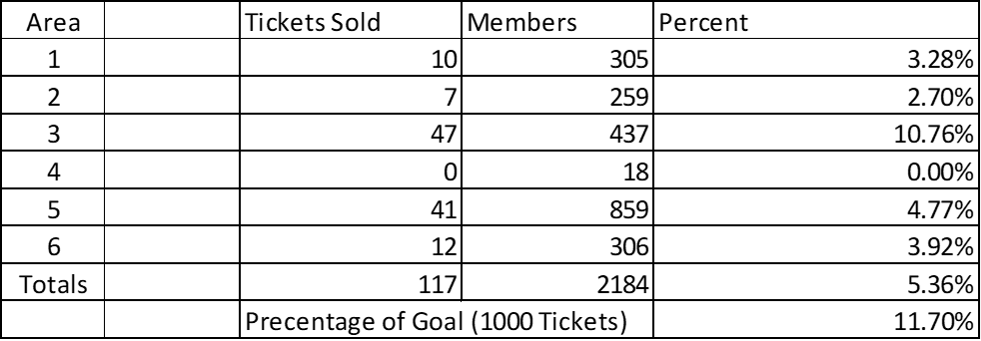

*The money raised in ticket sales will benefit the Legacy Run. Dennis and Kathleen are trying to get to events in every Area. They made the quilt and are traveling around the state on their own dime.
*Bob-Area 1 took up a collection of $163 at the President’s meeting to help offset the costs.
*Gene-Donations were made at the Area 5 President’s meeting.

- ALR CUP Mileage Summary

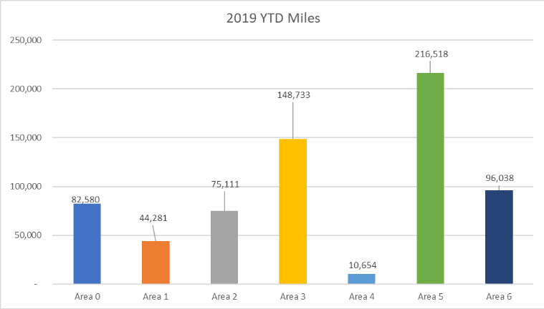

- Sick / Memorial
- Leonard Phillips surgery 10/4 speedy recovery
- Lefty went down after Area 1 President’s mtg.
- Jerry Kirby (Chapter 716 Los Alamitos) Rider Everlasting
- Sheryl Johnson (Chapter 852 Temecula) Rider Everlasting
- Rory Airheart had back surgery
- Vicky Legat (Chapter 852 Temecula) Rider Everlasting
- Rod Chater, (Chapter 50 Paso Robles) Rider Everlasting
- Patrick McDowell (Chapter 149 Escondido) very ill
- Monique requested emails with the names and addresses to send cards.

- Good of the Riders

*Rally-
*Chapter 28-Petluma. Brian Bokkin, Secretary, spoke about best roads for riding, that the chapter wants to be engaged, they are growing with 28 members and have a great facility. The Petaluma Veterans Building has been reserved for September 18, 19 and 20, 2020 from 6am until midnight. Planning on having dinner and raffles Friday. Breakfast, ride, lunch and dinner/dance Saturday. Breakfast on Sunday.
*Gene-Are there hotels? Response was that there are several hotels in Petaluma. More expensive area. Will try to get group rates.
*Motion to hold the 2020 West Coast Rally at Chapter 28 in Petaluma by Bob Perryman. 2nd by Fred Branson. Passed by vote of DEC.

*National Commander visit-
*Mike Smith-6 weeks out. Waiting on information to put out. The Commander comes into San Diego on December 11 and leaves San Francisco on December 17. Will be in San Diego for 2 days.
Mick-Working on the stops. Will be using the Wolfpack app so chapters can track the escort in real time. Larry Van Curan setting up the visit.

Vest –
*HOGS- were at our meeting and when we left it was dark. The HOG patches were reflective and showed up where the Rider patches you couldn’t see. There was discussion about having our patched done in reflective thread. Since the center patch comes from Emblem Sales, this would be hard to get the stitching in reflective. It was discussed about having Rey check with the Quartermaster to see about getting the top flare done in reflective gold thread. It will cost more but be better from a safety standpoint.

- Next Meeting Date – 21 November 2019 1900 or 7:00 PM Due to Thanksgiving

- Benediction - Monique Clemons

- Adjournment – President Rey Ruiz @ 8:32 PM

